Assignment 2

CSCI E-57

Nathan Hunt

15 November 2020

Assignment 2 execution instructions

2.1:

Prerequisite: running the following in MySql:

1. resources/db/ddl.sql
2. resources/sql/schema.sql
3. resources/sql/test-data.sql

Also, running mvn clean install

* find all books by category name:
  + java -jar target/assignment2_1-find-books-by-category-name.jar
  + Expected output:

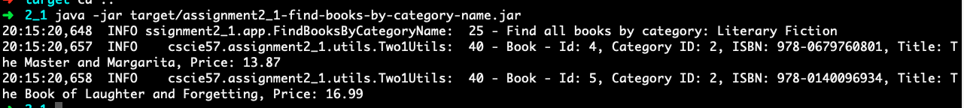

* find all categories:
  + java -jar target/assignment2_1-find-all-categories.jar
  + expected output:

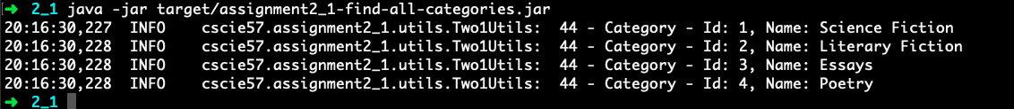

* find all books:
  + java -jar target/assignment2_1-find-all-categories.jar
  + expected output:

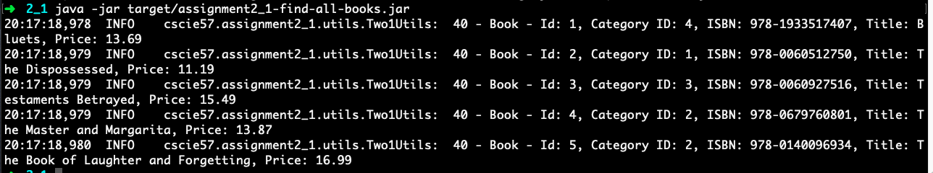

* insert a new book with existing category id:
  + java -jar target/assignment2_1-insert-new-book.jar
  + expected output:

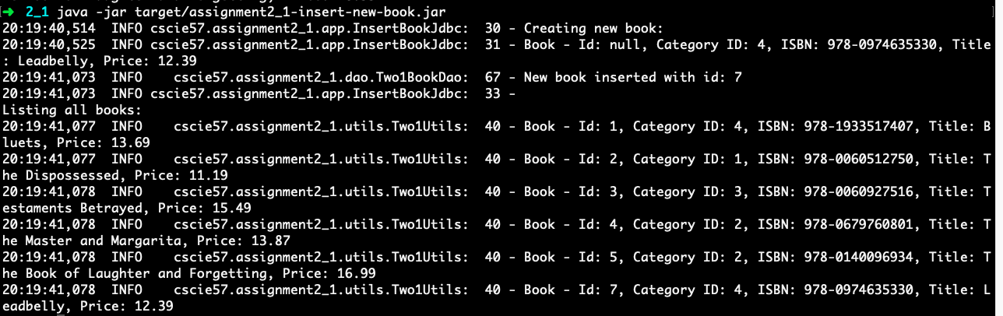

* find book with id=6. Update the book’s price, setting it to 39.99:
  + java -jar target/assignment2_1-update-book-price.jar
  + expected output:

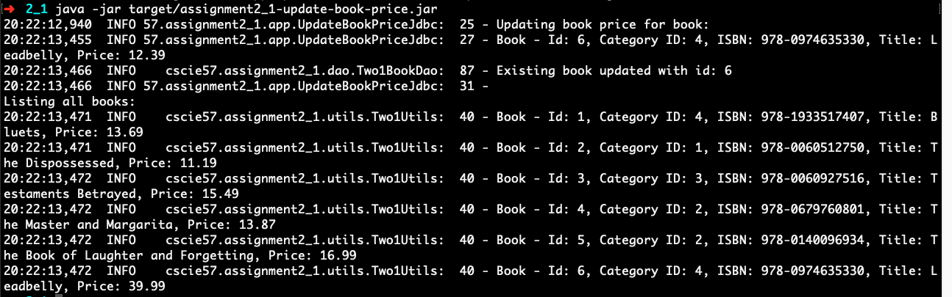

* delete the book with id=6:
  + java -jar target/assignment2_1-delete-book.jar

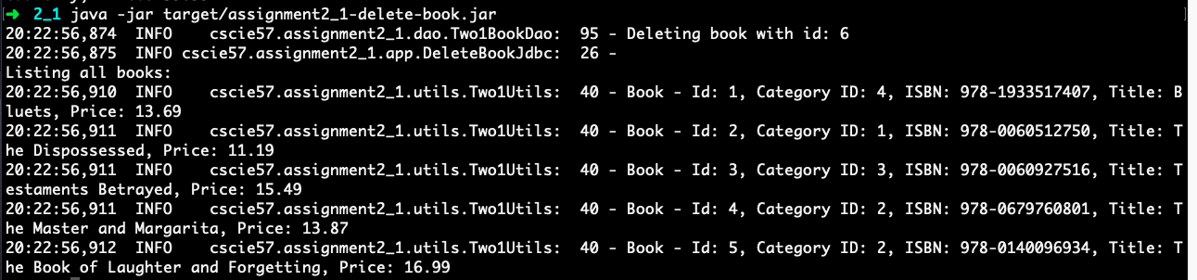

2.2:

Prerequisite: running the following in MySql:

1. resources/db/ddl.sql
2. resources/sql/schema.sql
3. resources/sql/test-data.sql

Also, running mvn clean install

* find all books without authors and categories:
  + java -jar target/assignment2_2-find-all-books.jar
  + expected output:

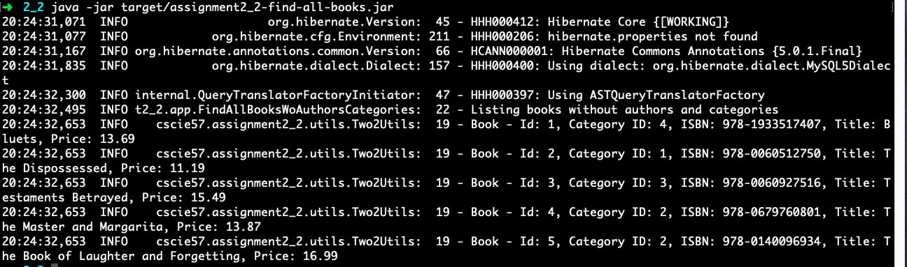

* find all books with authors and categories:
  + java -jar target/assignment2_2-find-all-books.jar
  + expected output (partial):

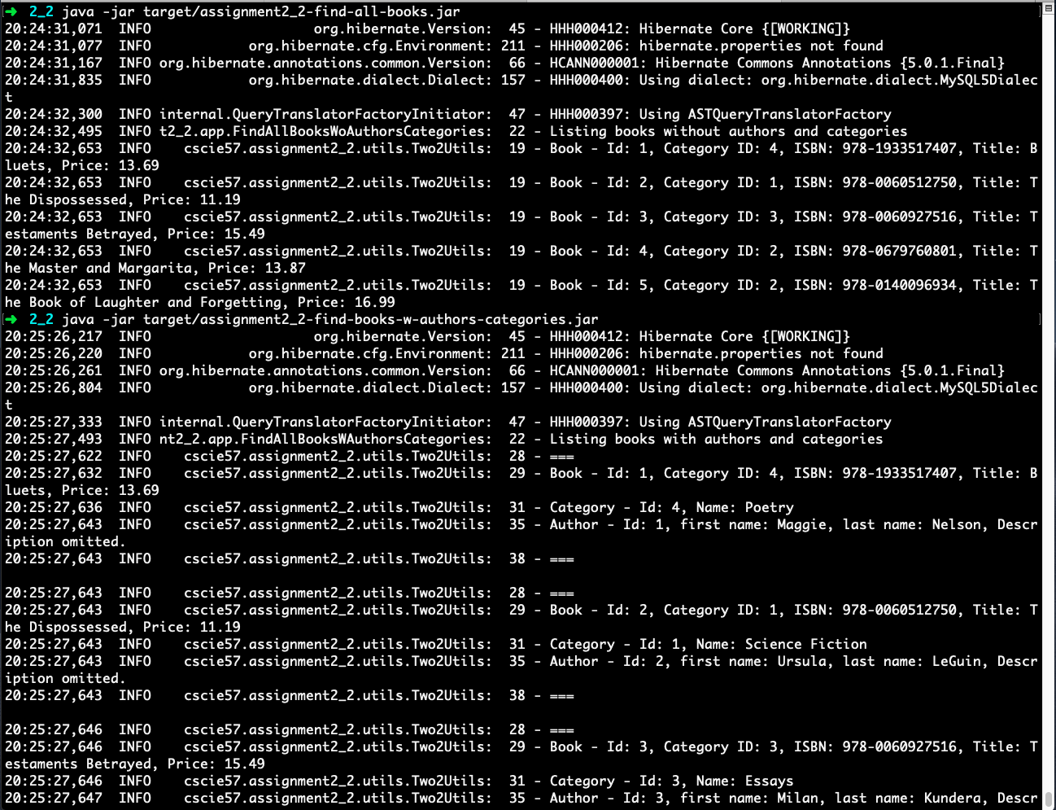

* find a book with authors and category by book’s ID
  + java -jar target/assignment2_2-find-book-by-id-w-authors-categories.jar
  + expected output:

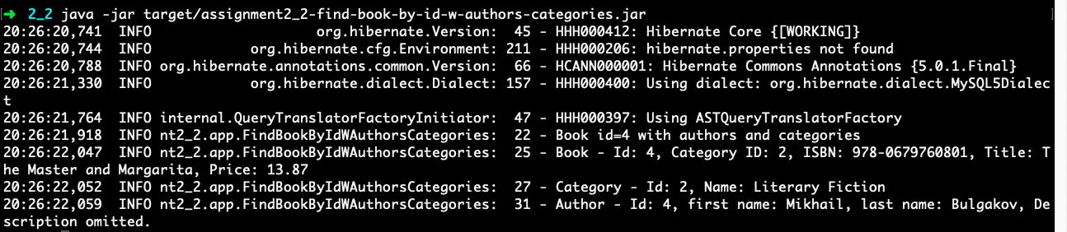

* find all books by author id
  + java -jar target/assignment2_2-find-book-w_categories-by-author-id.jar
  + expected output:

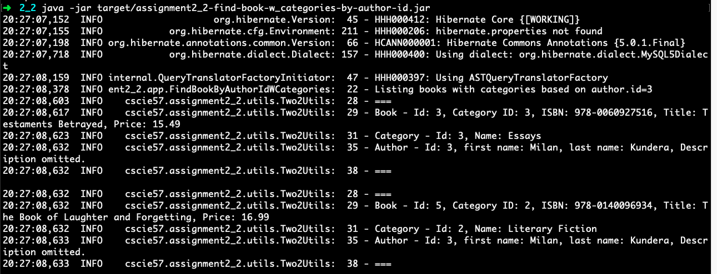

* create and delete books—I could not get this to work, unfortunately.

2.3:

Prerequisite: none for MySQL (reuses database from 2.2). Running mvn clean install.

* find all books without authors and categories:
  + java -jar target/assignment2_3-find-all-books.jar
  + Expected output:

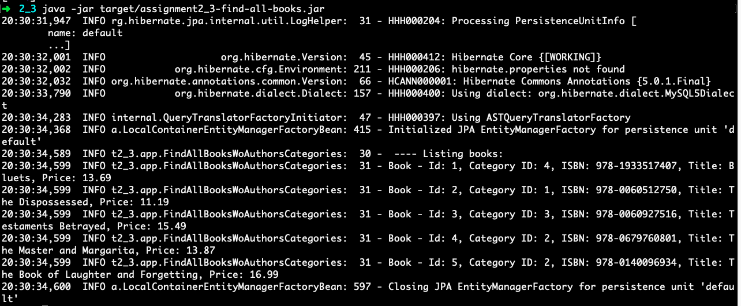

* find all books with authors and categories
  + java -jar target/assignment2_3-find-all-books-w-author-categories.jar
  + expected output (partial):

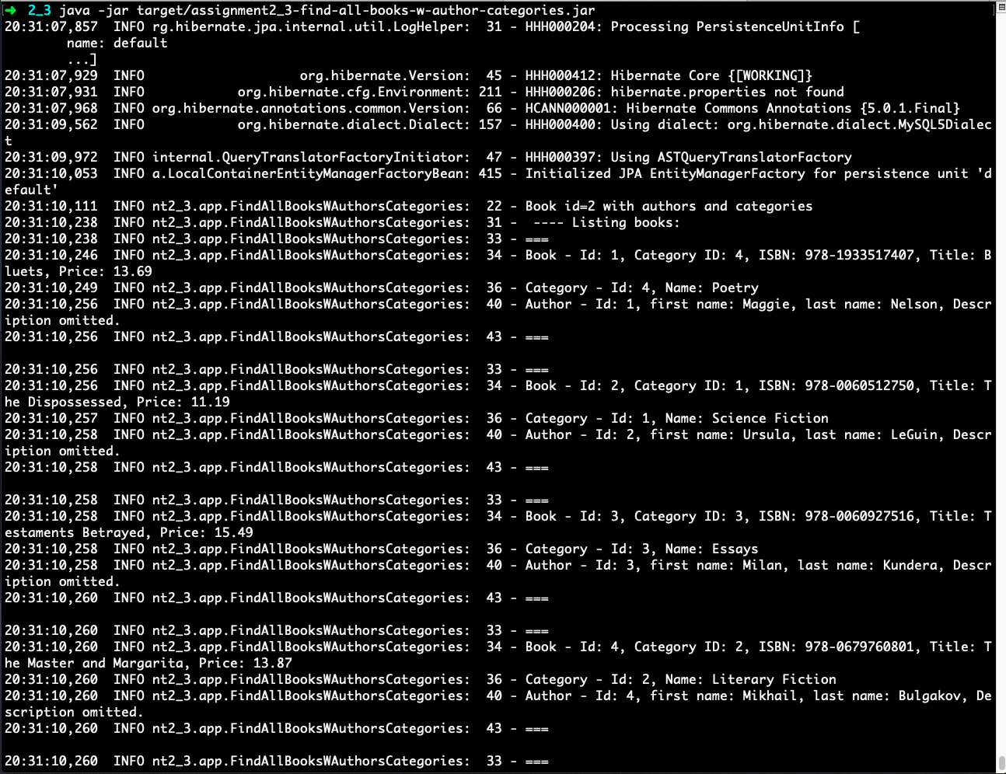

* find a book with authors and a category name by book’s ID
  + java -jar target/assignment2_3-find-book-by-id-w-authors-categories.jar
  + expected output:

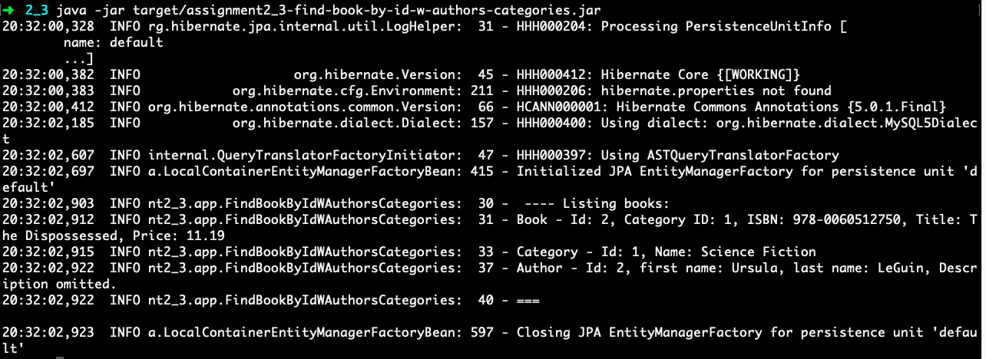

* I ran out of time for creation and destruction functionality
* Find all books by native queries. No authors and categories.
  + java -jar target/assignment2_3-find-book-native-query.jar
  + expected output:

